***Introduction to Design and Configure a Rapid Spanning Tree Protocol (STP) Network***

What it is and how it works on cisco devices.

***What Does STP Do?***

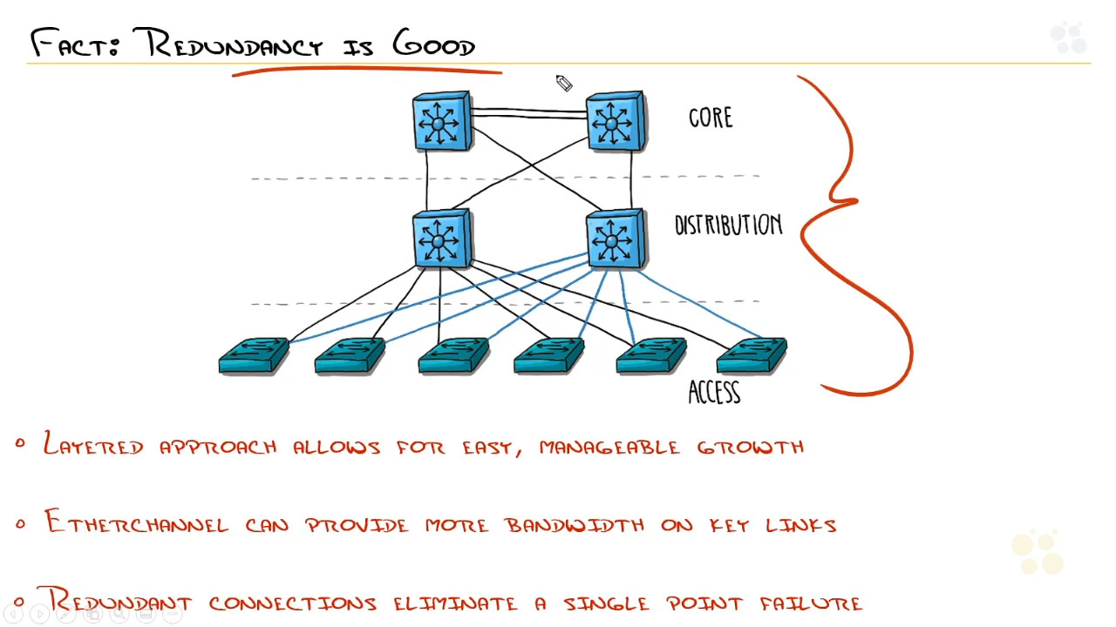

Rules of spanning tree: how stp finds the best path.

1. Elect the root bridge which is the oldest switch on the network.
2. Finds the best path on the network
   1. Lowest cost
      1. 10MBPS- cost 100
      2. 100mbps - cost 19
      3. 1gbps – cost 4
   2. Lowest bridge id
   3. Lowest port number
3. Block whatever is left over

In STP, which of the following criteria could be used to choose the best path(Choose three)

Lowest port number

Lowest bridge ID

Lowest cost

***Understanding STP Standards***

Common Spanning Tree (cst or stp – 802./d) 1993 50 seconds

Per-vlan spanning tree (PVST+) – spanning tree that works on each vlan.

Rapid Spanning Tree (rstp – 802./w) 2 seconds

Per-vlan Rapid Spanning tree (pvrst)

Multiple Spanning Tree Protocol ( MSTP – 802./s)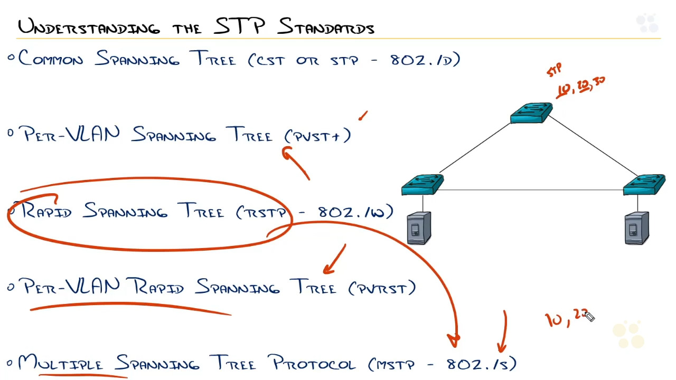

From the options below, which of the following are cisco proprietary versions of the stp standards?

PVRST and PVST+

***How the Root Bridge is Elected***

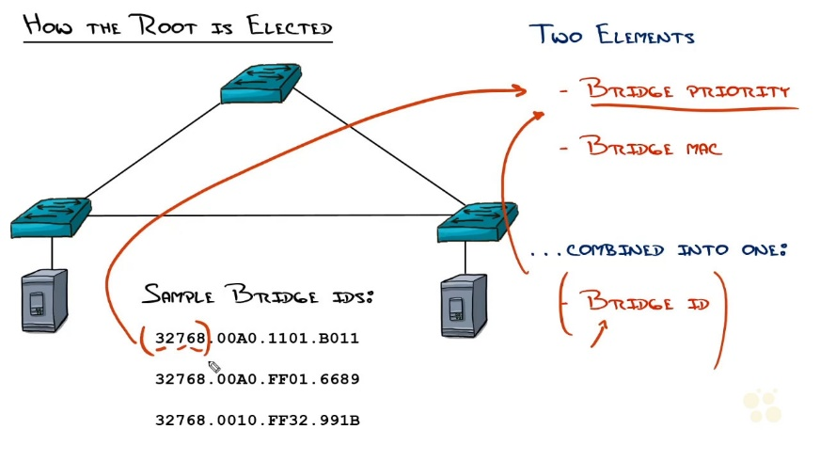

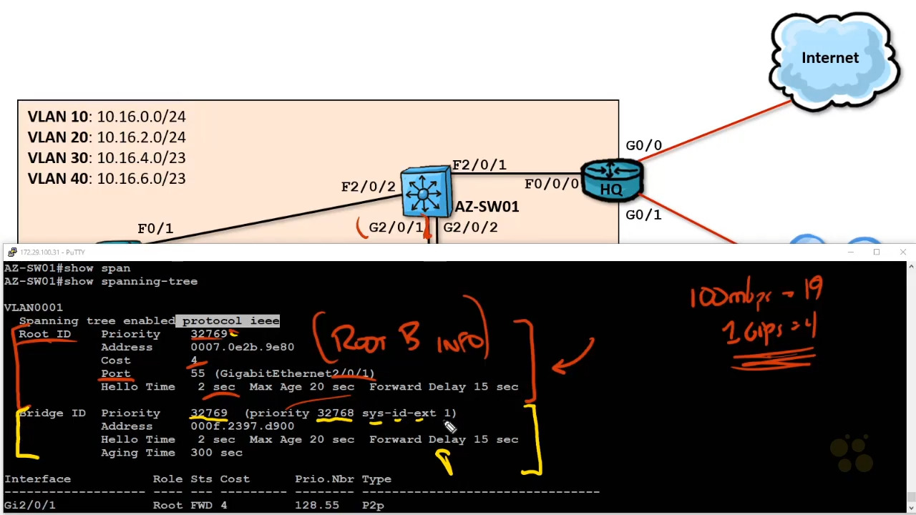

Which of the following criteria will be used to determine the root bridge?

The bridge id- consist of bridge priority and bridge mac address

***How to Determine Your STP Topology***

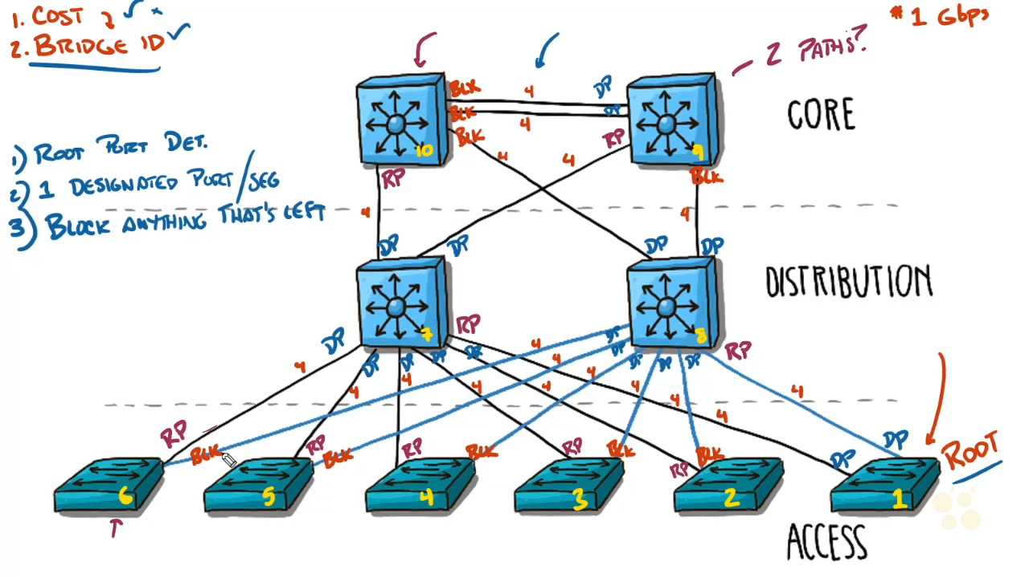

When two switches are determining which side of a network segment will be blocked, which criteria is used to determine the switch that'll have the designated port?

The switch with the lowest root cost

***Configuring Basic STP and Verifying Results***

#show spanning-tree

The most important thing when studying for the ccna is really how to configure thr root bridge

When you type in this command the ROOT ID is the switch that is the root and the bridge ID is the switch you are on.

First lets see how we can elect who the root bridge is.

#spanning-tree mode rapid-psvt

In order to gain the benefits of rapid-psvt all the switches must use this command.

Now we can look into making a switch the root bridge.

>#spanning-tree vlan 1,10,20,40 priority 4096

Which of the following is the default bridge priority value?

32768

***Identifying and Configuring STP Ports and Root Bridge Lab***

Which show command will tell you which switch is the current root bridge?

Show spanning-tree